Tutorial on IoT

Question 1

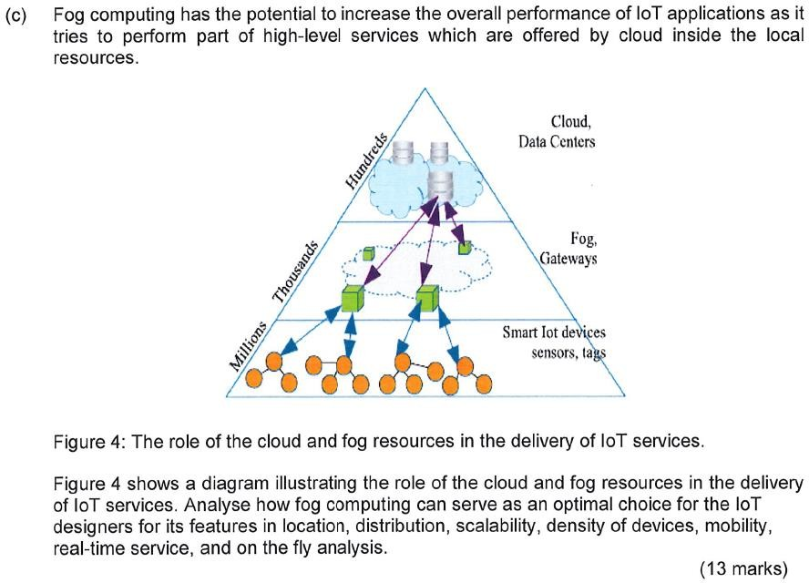

Question 2

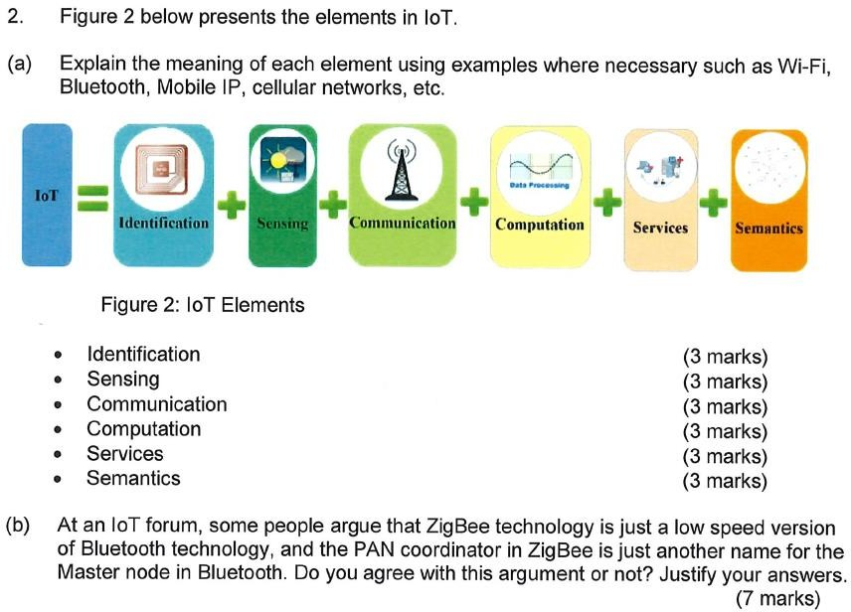

Question 3:

Use DODAG protocol to build a DODAG topology for the network below.

